IT Organization

Antti Pikkuaho

IT Organization

Fall 2017

Information Processing Sciences

Oulu University of Applied Sciences

# Organization structure and management

An IT organization is the department that is responsible for establishing, maintaining and monitoring IT systems and services. In a large organization they may also be responsible for strategic planning ensuring that business goals are being supported by the IT initiatives. Organizational structures vary and can be either centralized or decentralized. In a large business, the IT organization is usually managed by the CIO, Chief Information Officer. One example of such an organization is figure 1. Smaller organization can report to an operations manager or IT director. An example of such an organization is figure 2. (TechTarget, 2013.)

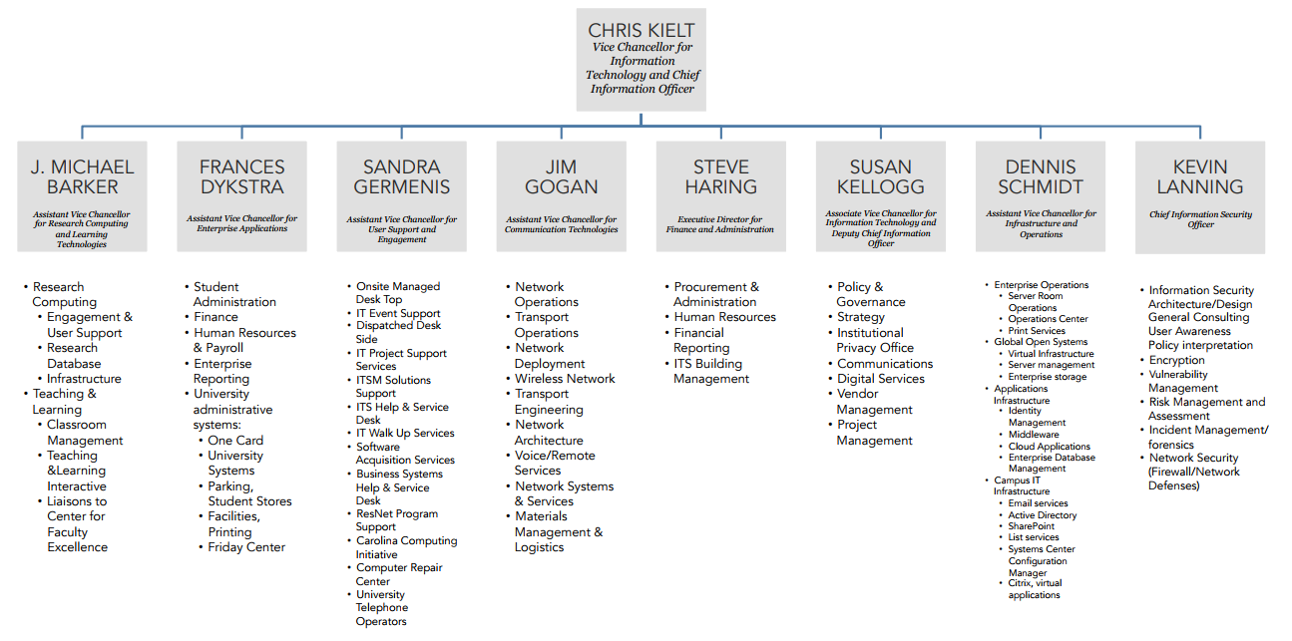FIGURE 1. UNC's IT organizational chart (University Of North Carolina. 2016).

*FIGURE 2. AGU’s IT organizational chart (Arabian Gulf University. 2010).*

As demonstrated by figure’s 1 and 2 organizational structure varies according to the needs of the organization. One clear commonality is that both have been illustrated as a formal organization (Wikipedia. Retrieved 7.1.2018). Another commonality is that there is a clear ‘leader’ either in the form of an IT director or CIO.

Both CIO and IT directors oversee the day-to-day technology needs of a company. They are both responsible for the operation of a company’s IT resources as well as requiring advanced understanding of network and data solutions. The ability to set goals and knowing how to manage budgets. The function, security and management of a company’s computing systems depends on the work of the CIO and IT directors. The main difference is the scale of responsibilities. “The CIO is is the head executive in charge of the entire IT department”. The IT director however is responsible for a small group of employees. The CIO creates and maintains the organizations IT strategy with focus on the long-term. IT directors are typically handling more immediate issues like hiring employees and implementing systems. (Study.com. Retrieved 7.1.2018.)

According to some sources IT director and CIO mean the same thing and the only difference is that CIO is used in American English while IT Directors are used in British English. The CIO is considered to one of the top managers in the organization. (ManagementMania. Retrieved 7.1.2018.)

However other sources state that IT directors, while not mutually exclusive since some directors are also managers, are not managers themselves and vice versa. It all depends on the structure of the corporation. Some executives hold both titles. Basically a director is a manager of managers while a manager oversees employees. (Kress R. 2016.)

IT management seems to be hard to define and place into a concrete structure because of all the variations in said structure and even in job descriptions and names of roles. However the managements role in an organization always remains the same. Management is divided into the activities concerning planning, leading, organizing and controlling as well as displaying strong knowledge in a discipline to guide and support others more effectively. Their role is about their team and their performance, not about themselves. The manager is responsible to their senior executives while also need to supply employees with support, motivation and guidance. (Reh J.F. 2017.)

# projects

The most important aspect of any work, one might argue, is starting and finishing successful projects. Any work with a goal or objective can be described as a project. BusinessDictionary defines project as a “planned set of interrelated tasks to be executed over a fixed period and within certain cost and other limitations” (Retrieved 7.1.2018).

Such projects are usually undertaken by a team of individuals, often from the same organization, using whatever tools are necessary for the project. The project can have a set manager guiding the team, setting deadlines and assignments and acting as the one who takes responsibility for the project for example. Such management can also be distributed among the team members as is the case with Agile Project Management, but even there the ScrumMaster and the Product Owner who take on more responsibility for the project. (VersionOne. Retrieved 7.1.2018.)

Projects are accomplished in steps. Project steps can be described by process groups:

**“Initiating processes –** Authorizing the project or phase”

**Planning processes –** Setting objectives and selecting the best of available courses of action that lead to accomplishing the objectives of the project.

**“Executing processes –** Coordinating people and other resources to carry out the plan.”

**Controlling processes –** Ensuring that objectives are met using monitoring and measuring and taking corrective action when necessary

**Closing processes –** Bringing the project to an orderly end.

(Project Management Institute, 2000.)

The above is a guideline and the steps may not be linear. Such is the case with iterative projects, for example, where the a cycle encompasses all of the project, but the cycle is divided into four phases, that are divided into iterations that might have multiple builds within them (Kruchten P. 2002). Iterative projects are then build out of ‘mini-projects’ that each iteration basically is. Requirements for the next iteration might change after finishing the first one. The project can respond to changes much easier than when compared to the traditional waterfall model. (Kroll P. 2004.)

Usually projects in the IT world take advantage of tools, enterprise software applications and services that are deemed necessary by management. Very common examples include:

**Version control services and applications.** Tracks changes and evolution of the project, keeps logs of who, why and when of a change as well as what the change was (O’Sullivan B. 2009). One example such an application is GitHub.

**Project management tools and applications.**  Used for project planning, task management, document sharing and collaboration, calendar and contact sharing, bug and error management as well as time tracking (Techopedia. Retrieved 7.1.2018). One example such an application is Trello.

**Communication applications.** “Communication software is an application or program designed to pass information from one system to another.” Usually a chat system mostly passing text, but might also be audio through Voice over Internet Protocol. (Techopedia. Retrieved 7.1.2018.) One example such an application is Slack.

**Repository and hosting services.** A service that provides servers for organizations and individuals, making it possible for the content provided to actually reach the consumer (Wikipedia. Retrieved 7.1.2018). Some hosting services host repositories, that store metadata for a set of files or directories allowing easy duplication and modification (Wikipedia. Retrieved 7.1.2018). One example such an application is Bitbucket.

**Synchronization services**. Some hosting services provide file synchronization as well. One such service is Google Drive. Data synchronization means that multiple copies of the data are maintained and kept coherent with each other. Synchronization provides the means to share resources via file handling, network connections and memory. (Techopedia. Retrieved 7.1.2018).

References

[Arabian Gulf University. 2010. Information Technology Chart. Cited 7.1.2018, http://www.agu.edu.bh/english/units/IT_chart.aspx](http://searchcio.techtarget.com/definition/IT-organization-information-technology-organization)

BusinessDictionary. Retrieved 7.1.2018 Project – Definition. Cited 7.1.2018, http://www.businessdictionary.com/definition/project.html

Kress R. 2016. Director vs. Manager: What You Need to Know To Advance to the Next Step. Cited 7.1.2018, https://www.ivyexec.com/executive-insights/2016/director-vs-manager-what-you-need-to-know-to-advance-to-the-next-step/

Kroll P. 2004. Transitioning from waterfall to iterative development. Cited 7.1.2018, https://www.ibm.com/developerworks/rational/library/4243.html

Kruchten P. 2002. Planning an Iterative Project. Cited 7.1.2018, https://www.ibm.com/developerworks/rational/library/2831.html

O’Sullivan B. 2009. Mercurial: The Definitive Guide. Cited 7.1.2018, http://hgbook.red-bean.com/

Project Management Institute. 2000. A Guide to the Project Management Body of Knowledge (PMBOK® Guide). Pennsylvania:Project Management Institute Inc.

Reh J.F. 2017. The Role and Responsibilities of a Manager. Cited 7.1.2018, https://www.thebalance.com/what-is-a-manager-2276096

Study.com. Difference Between CIO and IT Director. (date unknown). Cited 7.1.2018, https://study.com/articles/difference_between_cio_and_it_director.html

Techopedia. Retrieved 7.1.2018. Communication Software. Cited 7.1.2018,

https://www.techopedia.com/definition/25706/communication-software

Techopedia. Retrieved 7.1.2018. Project Management Software. Cited 7.1.2018, https://www.techopedia.com/definition/13132/project-management-software

Techopedia. Retrieved 7.1.2018. Synchronization. Cited 7.1.2018,

https://www.techopedia.com/definition/13390/synchronization-dot-net

TechTarget. 2013. IT organization (information technology organization). Cited 7.1.2018, http://searchcio.techtarget.com/definition/IT-organization-information-technology-organization

University of North Carolina. 2016. UNC Information Technology Services – Organizational Chart: Leadership Team. Cited 7.1.2018, https://its.unc.edu/files/2016/11/OrgChart-October2016.pdf

VersionOne. Retrieved 7.1.2018. What is Agile Project Management. Cited 7.1.2018 https://www.versionone.com/agile-project-management/

Wikipedia. Internet hosting service. Cited 7.1.2018. Retrieved 7.1.2018,

https://en.wikipedia.org/wiki/Internet_hosting_service

Wikipedia. Organizational architecture. Cited 7.1.2018. (date unknown), https://en.wikipedia.org/wiki/Organizational_architecture

Wikipedia. Repository (version control). Cited 7.1.2018. Retrieved 7.1.2018,

https://en.wikipedia.org/wiki/Repository_(version_control)